Date

Dear representative,
We are seeking donations for a silent auction to support our high school choir’s trip to Ireland in June of 2024. I am Jay Hill. I am the Minister of Music at Vista Grande Baptist Church here in Colorado Springs. At Vista Grande, part of our mission is to partner with those working in churches overseas. We do this by sending groups to support their work and to encourage them. We have been sending the high school choir to Ireland periodically since 2014. Music resonates with the Irish. The presence and music of the teens opens doors for the building of relationships that help our friends and their church. We have sung in community centers, churches, cathedrals and pubs. We have been invited back and are planning to take a new group of high schoolers this June. Any support or donation that you would consider providing will go to help this student and the team make the trip affordable. We are grateful for your consideration.
If you have questions, you can reach me at Vista Grande Baptist Church, 5680 Stetson Hills Blvd, 719-598-2139.
You can contact our student or parent representative at:
Name:
Address:
Phone number:
Email address:
Student or parent signature:

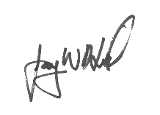
Yours truly,

Jay W. Hill

